SATISH CHANDRA MEMORIAL SCHOOL
CLASS: VII
Mathematics
HOTS + Assertion-Reason Based Questions Practice Exam
Maximum Marks: 16 Time: 40 minutes
SECTION A (HOTS)
$$1. Solve the equation: [2+2=4]$$
$$3 \left(5x – 7\right)+ 2\left(9x – 11\right)= 4\left(8x – 7\right)–35$$
$$Put the value of x from the equation in the following algebraic expression and find its value:$$
$$7x^{2}-13x+5$$

$$2. Find the value of y for which 2^{2y-6}×2^{3}=512 [3]$$
$3.Find the area of the figure given below.[4]$ 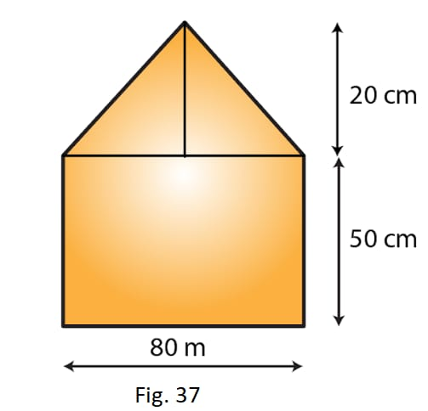

SECTION B
(Assertion-Reason Based Questions)$[1×5=5]$

$$Directions:Question no. 4-8 are Assertion \left(A\right)and Reason \left(R\right) based questions$$
$$carrying 1 mark each. Two statements are given, one labelled as-$$
$$Assertion \left(A\right) and the other is labelled as Reason \left(R\right). Select the correct option from$$
$$the codes\left(a\right),\left(b\right), \left(c\right), \left(d\right)as given below$$

$$\left(a\right) Both Assertion\left(A\right)and Reason\left(R\right)are true and Reason\left(R\right)is the correct explanation$$
$$of Assertion(A).$$
$$\left(b\right) Both Assertion\left(A\right)and Reason\left(R\right)are true but Reason\left(R\right)is not the correct explanation$$
$$of Assertion\left(A\right).$$
$$\left(c\right) Assertion(A) is true but Reason(R) is false.$$
$$\left(d\right) Assertion(A) is false but Reason(R) is true.$$

$$4. Assertion\left(A\right):The number of lines of symmetry and the order of rotational symmetry of$$
$$a parallelogram is same.$$
$$Reason\left(R\right): For a regular polygon, number of lines of symmetry=order of rotational symmetry$$

$$5. Assertion\left(A\right):The center of rotation for an equilateral triangle is the intersecting point of$$
$$its three angle bisectors.$$
$$Reason\left(R\right): For equilateral triangle, the medians divide the interior angles of the triangle into$$
$$two equal halves.$$
$$6. Assertion\left(A\right): If 2x+5=7, then 2x+5+2=7+2$$
$$Reason\left(R\right):For solving an equation , we can add or subtract the same number from the both sides of the$$
$$equation.$$
$$7. Assertion\left(A\right):The number 25689734 can be written in the standard form as 2.5689734×{10}^{7}$$
$$Reason\left(R\right): Any number can be expressed as a decimal number between 1.0 and 10.0 including 1.0 ,$$
$$multiplied by a power of 10.$$
$$8. Assertion\left(A\right):Perimeter of a square=4×length of one side.$$
$Reason\left(R\right): Perimeter of a regular polygon=number of sides×length of one side$

